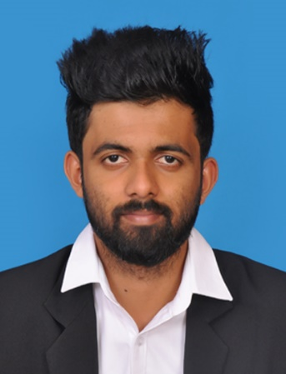

**Email**

[ashanrajapaksha954@gmail.com](mailto:ashanrajapaksha954@gmail.com)

**Phone**

+94 (76) 647 5044

**Address**

Vijayanthi Stores , Maussakanda, Bulutota

**Date of Birth**

20 August 1995

**Accounts**



**Contact Informations**

**Ashan Rajapaksha**

I am a student of University of Colombo School of Computing. I am a punctual and motivated individual who is able to work in a busy environment and produce high standards of work. I am an excellent team worker and am able to take instructions from all levels and build up good working relationship with others. Love to help others and contribute to open source community.

**Education**

**University of Colombo, School of Computing**

(2018 – To date)

**B.Sc. in Computer Science (Reading )**

Expected graduation year : 2021

**Embilipitiya Maha Vidyalaya**

(2012-2014)

**G.C.E. Advanced Level (2016)**

Physical Science (ABB)

Z-Score : 1.57

**G.C.E. Ordinary Level (2011)**

Passed with (A4 B2 C3)

[](https://stackoverflow.com/users/11689804/ashan-rajapaksha)[](https://medium.com/@ashanrajapaksha954)

**Skills**

Angular Js

React

Spring Boot

React Native

Node Js

Express Js

SQL

MongoDB Firebase Bootstrap

CSS / SCSS

Git

Postman

Java

C / C++

JavaScript TypeScript

Scala

Python

Html

Php

**Technology Exposed**

**Languages Exposed**

**Projects**

**E-Supervision**

**React JS | MongoDB | Node JS | Express JS | Bootstrap**

This is my 3rd-year group project at university. E-Supervision is an IT project supervision platform specially design for universities.

**Student Registration System**

**Java | MySQL**

A Mini project for a school system

**E-Heaven**

**Angular 8 | MongoDB | Express JS | Node JS | Bootstrap | Material**

This is my 2nd-year group project at university. This is a School Management System. This System can manage all the academic activities . design for St. Jones Collage, Nugegoda.

My Notice Board is a mobile application which helps to manage official notice board.

**My Noticeboard**

**React Native | Firebase**

Software Engineering

Web Development

Mobile Application Development

Problem Solving

Socialization

Coding

Badminton, Carrom , Volleyball

Travelling and Hiking

**Professional**

**Personal**

**Interests**

* **Versus Covid – E-heaven**
* **National Top 10 | EH4 Group**
* Hackathon for island wide universities organized by IEEE, branch, University of Peradeniya.
* **Inter Faculty Freshers meet**
* Triple Jump – 1st Place
* Badminton - 2nd place
* Cricket - 2nd runners up
* Elle - 2nd runners up

**Achievements**

**References**

**Certifications**

**Dr. Thilina Halloluwa**

Lecturer,

University of Colombo School of Computing.

[tch@ucsc.cmb.ac.lk](mailto:tch@ucsc.cmb.ac.lk)

+94 (77) 722 9245



* Introduction to Relational Database and SQL
* Git for developers using Git Hub
* React – Redux Course – Solo Learn
* JAVA fundamental course – Solo Learn
* SQL fundamental course – Solo Learn

**Mr. Isuru Dharmadasa**

Lecturer,

University of Colombo, School of Computing

imd@ucsc.cmb.ac.lk



**Involvements**

* **Mozilla Club of UCSC**
* Committee member of Mozilla club
* Committee member of ISACA
* **Shilpa Sena-2019**
* Volunteered as a UCSC representative at Shilpa Sena which was a science, technology and research exhibition held by the ministry of Science Technology and Research

**Certificates Obtained**

[GCP Fundamentals–Core Infrastructure](https://www.coursera.org/account/accomplishments/records/HMYSHRWNRZQN)